Floating-Point Data Types
# Source: AI Source: Provided by: [Data Path: Persons Table -> ID Column: 1, Name_En Column: Motasem Essam] -> From: [Chatgpt (GPT‑5 Mini)] on [12/10/2025]
Floating-Point or Float or Decimal is a data type used to store numbers that contain a fractional part (numbers with a decimal point).

Key Characteristics
# Source: AI Source: Provided by: [Data Path: Persons Table -> ID Column: 1, Name_En Column: Motasem Essam] -> From: [Chatgpt (GPT‑5 Mini)] on [12/10/2025]
- Can store numbers with decimals
- Can represent very large or very small values
- Used in scientific calculations, measurements, and precise values

Examples of Float Values
# Source: AI Source: Provided by: [Data Path: Persons Table -> ID Column: 1, Name_En Column: Motasem Essam] -> From: [Chatgpt (GPT‑5 Mini)] on [12/10/2025]
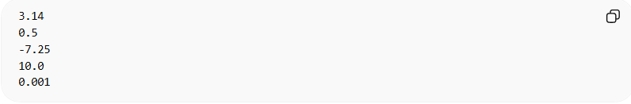
3.14
0.5
-7.25
10.0
0.001

Example in Programming

Python
# Source: AI Source: Provided by: [Data Path: Persons Table -> ID Column: 1, Name_En Column: Motasem Essam] -> From: [Chatgpt (GPT‑5 Mini)] on [12/10/2025]
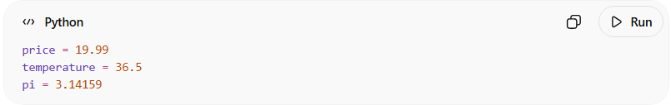
price = 19.99
temperature = 36.5
pi = 3.14159

C / C++ / Java
# Source: AI Source: Provided by: [Data Path: Persons Table -> ID Column: 1, Name_En Column: Motasem Essam] -> From: [Chatgpt (GPT‑5 Mini)] on [12/10/2025]
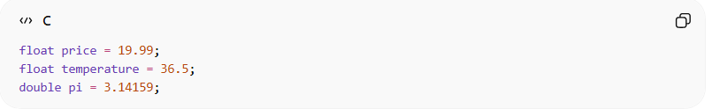
float price = 19.99;
float temperature = 36.5;
double pi = 3.14159;

Common Floating Types
# Source: AI Source: Provided by: [Data Path: Persons Table -> ID Column: 1, Name_En Column: Motasem Essam] -> From: [Chatgpt (GPT‑5 Mini)] on [12/10/2025]
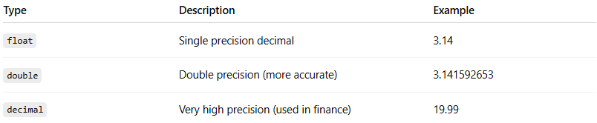
Type | Description | Example
float | Single precision decimal | 3.14
double | Double precision (more accurate) | 3.141592653
decimal | Very high precision (used in finance) | 19.99

Where Float/Decimal Are Used
# Source: AI Source: Provided by: [Data Path: Persons Table -> ID Column: 1, Name_En Column: Motasem Essam] -> From: [Chatgpt (GPT‑5 Mini)] on [12/10/2025]
- Measurements (height, weight, temperature)
- Scientific calculations
- Money values
- Percentages
- Physics or engineering calculations

Example Use Case
# Source: AI Source: Provided by: [Data Path: Persons Table -> ID Column: 1, Name_En Column: Motasem Essam] -> From: [Chatgpt (GPT‑5 Mini)] on [12/10/2025]
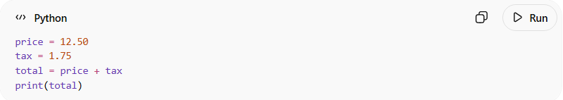
price = 12.50
tax = 1.75
total = price + tax
print(total)
Result: 14.25
Difference Between Integer and Float
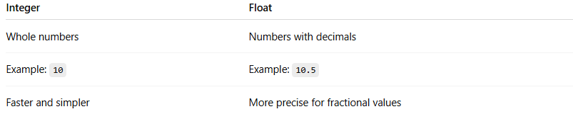
Integer | Float
Whole numbers | Numbers with decimals
Example: 10 | Example: 10.5
Faster and simpler | More precise for fractional values

